Vietnam

Vietnam is a Southeast Asian country on the South China Sea known for its beaches, rivers, Buddhist pagodas and bustling cities. Vietnam bordered by China to the north, Laos to the northwest, Cambodia to the southwest, and Malaysia across the South China Sea to the southeast. Hanoi is the capital of the country.

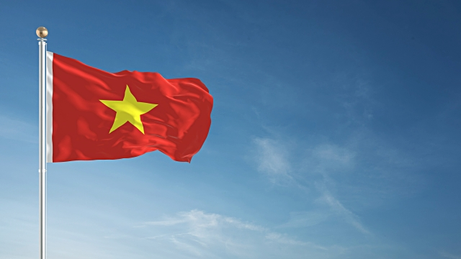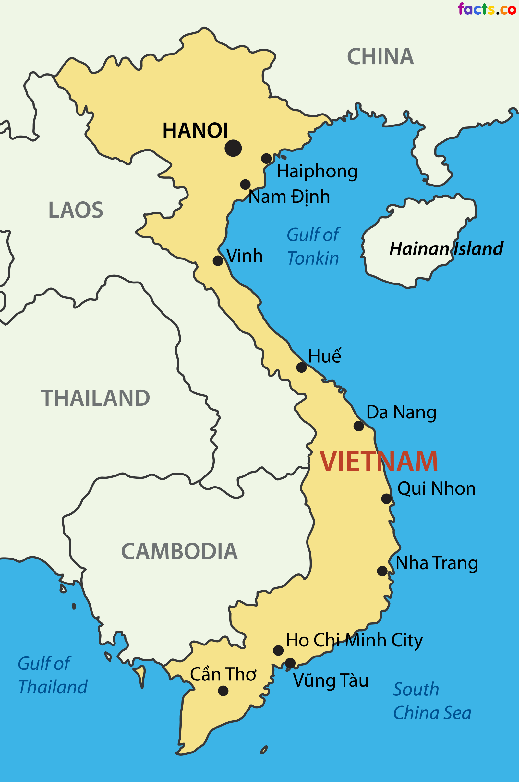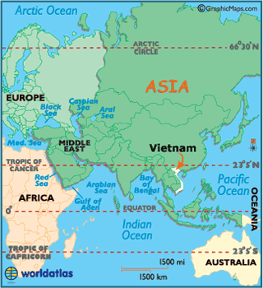

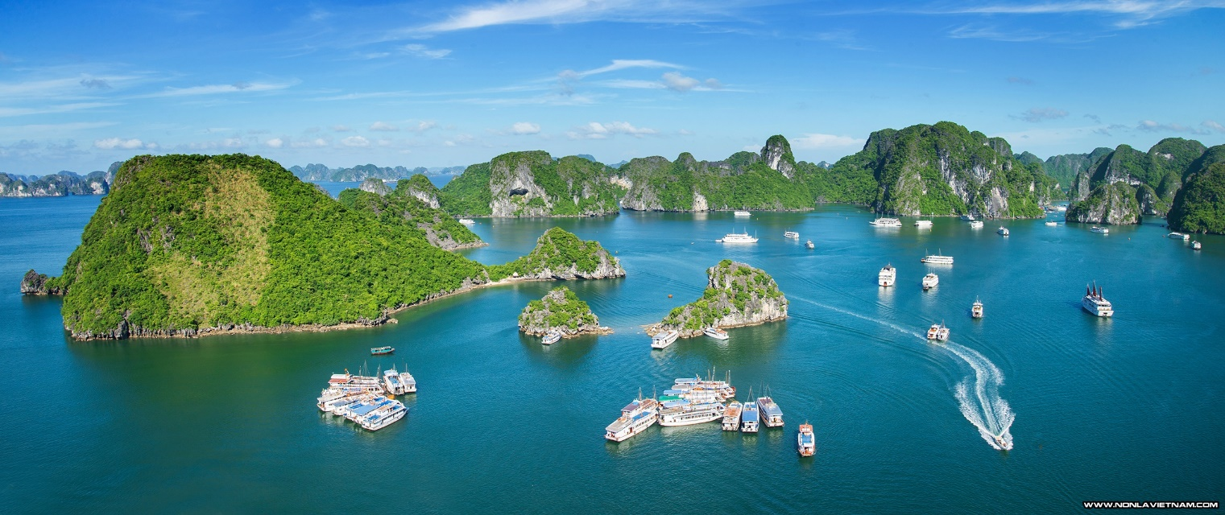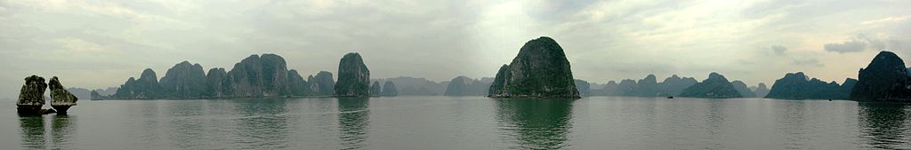Ha Long Bay is the UNESCO World Heritage Site.

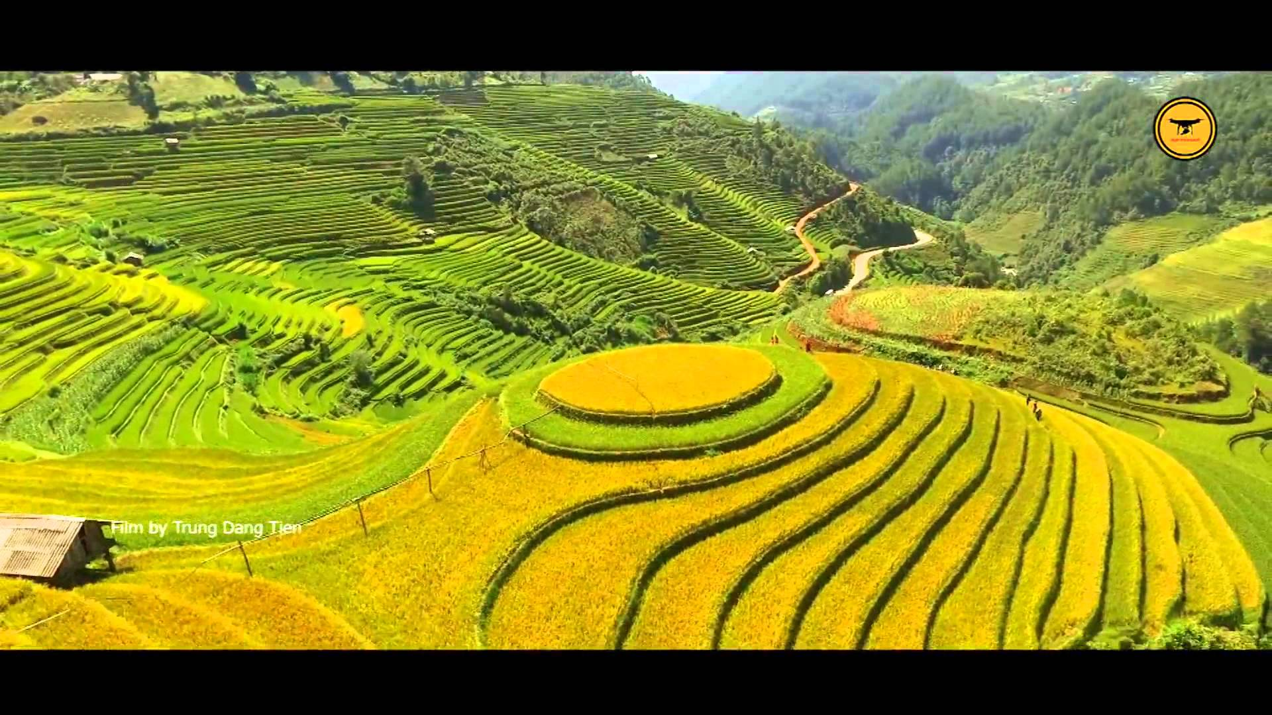

The Ao Dai is a Vietnamese national costume, now most commonly worn by women but can also be worn by men. In its current form, it is a tight-fitting silk tunic worn over pants.

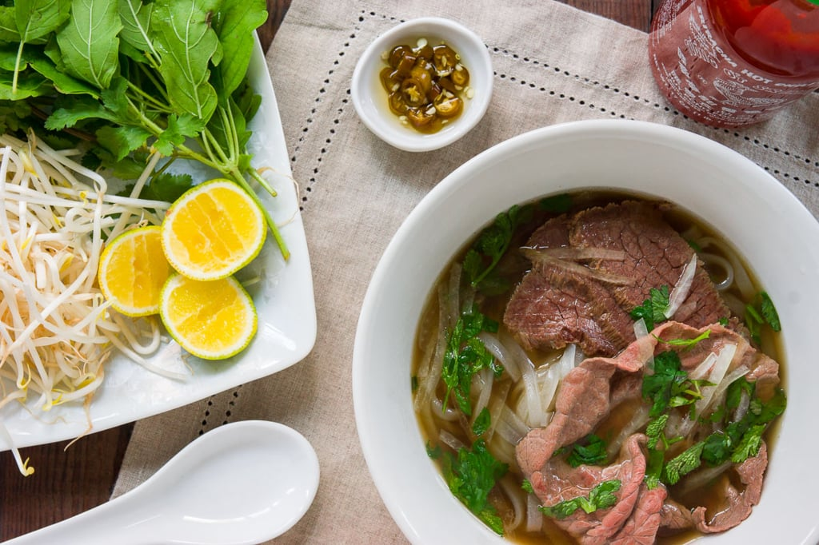 Pho was popularized throughout the rest of the world by refugees after the Vietnam War. Pho is a Vietnamese noodle soup consisting of broth, rice noodles called bánh phở, a few herbs, and meat, primarily made with either beef or chicken. It is a popular street food in Vietnam and the specialty of a number of restaurant chains around the world. Vietnamese people usually consume it at any time of day.